



BRANCH NEWS JUNE 2022
Registered charity No. 106918

It is so good to be able to report that dancing is gradually re-starting around the Branch, to varying degrees and in varying styles, but slowly getting nearer to the former reality. I’m sure we’re all pleased that many local groups and regular classes are functioning again. I’ve included details insofar as I have them. Please keep me updated on the local scene.

And it’s particularly encouraging that some of our previous favourite special events have again become possible. Recently, these have included our Annual Ball, which was finally able to take place in Penarth in April. (See pages 2 & 3).

The Tredegar House Dance Festival in Newport (Gwent) happened again this May, the first time since 2019, with Branch dancers able to provide a mixed team from a number of different groups. (Photos below and on page 3.)

We’re also delighted to learn that regular third Saturday of the month dances have started again on a trial basis in Swansea (with one already held in May, and one planned for June).

SCHOLARSHIP
Scilla Allaway has informed me that the - sadly now defunct - group in Bulith Wells has kindly donated their remaining funds to a scholarship at the RSCDS Summer School, with preference to be given to South Wales dancers. Please spread the word on this – it would be great if in 2023 someone from our Branch could benefit from the Builth group’s generosity.
Alison Jackson, Branch Secretary

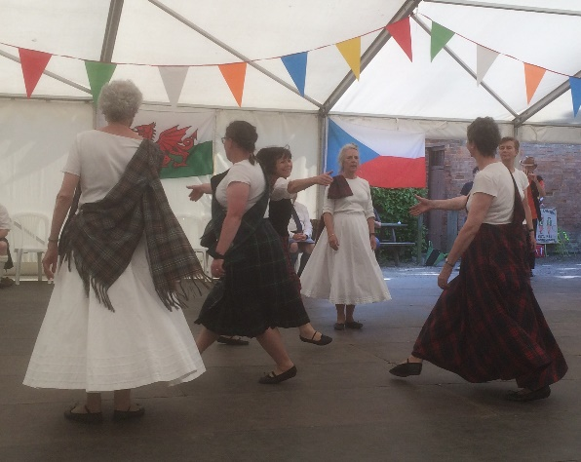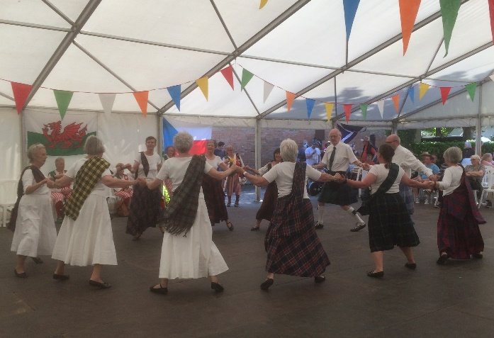
Tredegar House Festival 8 May 2022
All photos by Alison Jackson

SOUTH WALES FESTIVAL OF DANCE
The Festival has returned! It is taking place on Saturday 25 June. Dancing in the afternoon will take place at the Brecon Beacons Visitor Centre (if the weather’s fine), and at the Maescar Community Hall in Sennybridge in the event of rain (2:00 pm either way). The evening dance will be held at the Maescar Hall (7:00 pm). Full details are available on fliers which have been distributed. Please let me know if you need further information.
As most of you know, we usually have several demonstration teams taking part, so that the afternoon programme consists of easy social dancing (a mixture of country dance and ceilidh, encouraging family members, friends and onlookers to join in), with several slots for demonstrations.
This year we are organising the demonstrations slightly differently, and commemorating the dancers we have lost since our last Festival in 2019. Sadly, the total is nine dancers, not all Branch members, but all significant in Scottish Country Dancing in South Wales. To celebrate them we have chosen their favourite dances, or dances in some way associated with them, as far as possible in consultation with their relatives and friends. As a result, many of the selections will be well known and well loved dances. So in some cases we’ll be repeating the dance with audience participation.
Those taking part in the demonstrations will be a mixture of dancers from different groups, Please come along and support them.

SOUTH WALES BALL
This event took place on Saturday 23 April, again the first time since 2019. Music was provided by Nicol McLaren and his Glencraig Band, and the venue was the Paget Rooms in Penarth.

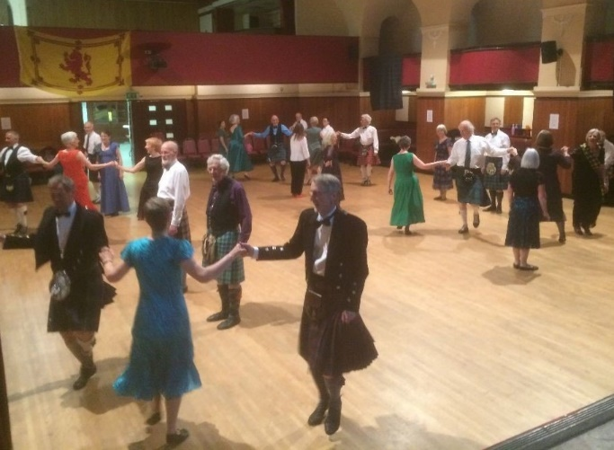
Dancing Napier’s Index
(All photos by Alison Jackson)
We had been somewhat anxious about numbers, as we were aware that generally there was still quite a lot of nervousness about attending public events. In the end we had just over forty dancers, which although not filling the hall allowed for a good ambiance. We are particularly grateful to Bristol Branch for their support: half of those present were from the Bristol area, with several others from further afield.
Here are just some of the comments we received, starting with one from the band:
We really enjoyed the gig on Saturday - great atmosphere and synergy.
It was a lovely evening, the band was great, the food good and the dancing excellent.
I very much appreciated your recapping, especially always repeating the instructions for the first few bars. I don't think I'm alone in immediately forgetting how the dance started!
It was a really good evening and the lower numbers meant plenty of room to dance!!
The atmosphere was fantastic. Nicol did a grand job lifting us to a high level of enjoyment.
Just to say how much we enjoyed Saturday evening - the music, the dancing, the meal and meeting everyone again after such a long time.
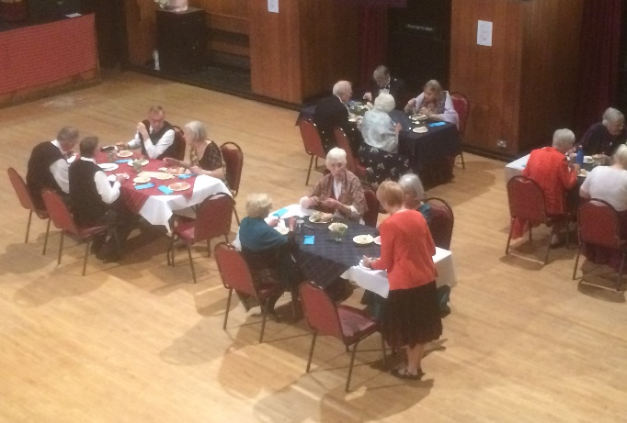

It was exhilarating to dance to Nicol and his band again, and we all enjoyed every minute. Thank you to all the organisers.
Thank you to you and the rest of the South Wales team who organised such a great event. Good venue, fun programme, excellent band and terrific recapping. The atmosphere was brilliant and well worth the petrol money!
Nicol and the band were great, really good lively music and the supper was very well managed- Carol’s flowers for the tables such a delightful touch.
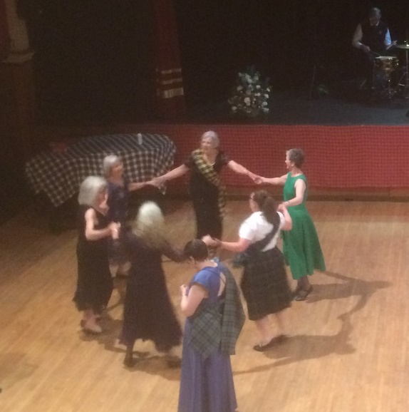

Thanks for all your hard work, not least your great recaps. It was a great evening lovely atmosphere. Good journey home.
TREDEGAR HOUSE FESTIVAL, NEWPORT, 8 MAY 2022

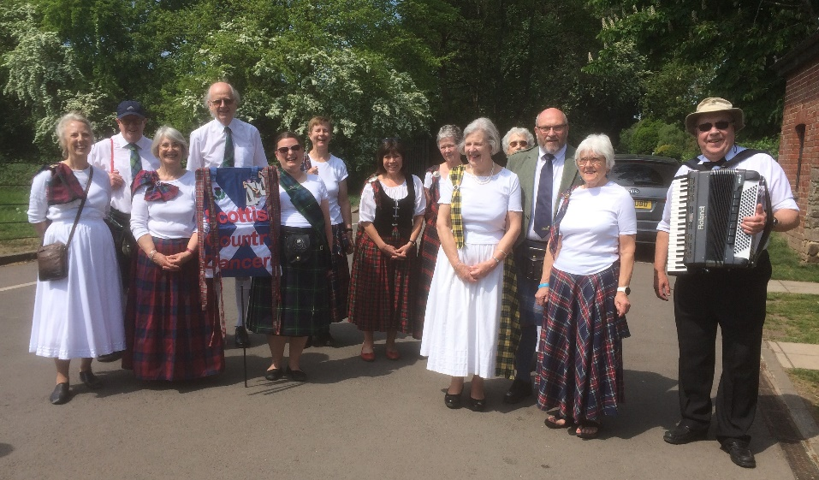
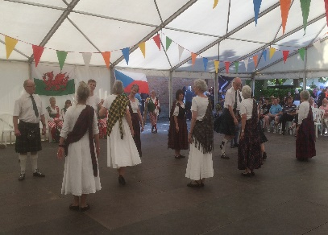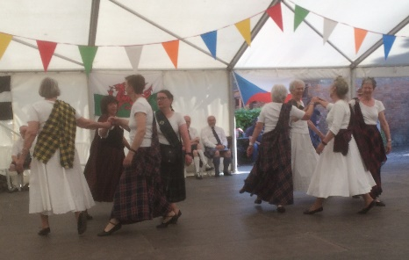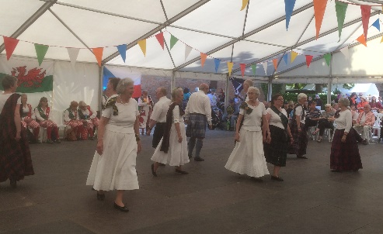
DETAILS OF LOCAL GROUPS
WEST WALES
Pat Rye’s class:
Village Hall in Houghton every Monday in term-time at 7:00 pm.
Contact: Pat Rye ryedp@hotmail.com

Heather Davies’s class:
Wednesday evenings 7-9pm in Uzmaston Hall for a beginners/intermediate class. We also meet some Fridays for social dancing.
Negative LFT required.
Contact Heather8.davies@gmail.com or 07970772684

Jean Elliott’s class:
Meets weekly in Narberth on Thursdays from 7:30 – 10:00 pm.
Contact: Jean Elliott jean.ell1@btinternet.com

SOUTH CENTRAL AND MID-WALES

SWANSEA
St Andrew’s Club on Wednesdays at the Scout Hut, Swansea
Contact: Jim & Jan Proudfoot jimnjan@ntlworld.com
PORT TALBOT
This group meets on Tuesday evenings from 7:30 – 9:30 pm in the Carmel Welsh Presbyterian Church Hall, Port Talbot SA13 1PQ
Contact Ann Morgan a_e_morgan@lineone.net or Tony Harland anthony.harland@anthonyh102.plus.com

BRECON
The Brecon group was re-starting tentatively in the autumn of 2021, but at that stage was not encouraging new members. I have had no further updates since then.
Contact: Peter Brock pbrock14@yahoo.com

CELTIC LINKS – COMBINED GROUP
Gwenda Dinsdale has set up a group for dancers who wish to be challenged and who are willing to travel (about every 4-6 weeks, usually in the .Community Hall in Hirwaun, on a Sunday between 12:00 and 2:30..
Contact: Gwenda Dinsdale
01874676277 or (for texts only) 07837320372
gwendadinsdale@talktalk.net

SOUTH-EAST WALES
VALE OF GLAMORGAN:
Since October Lyn Wilson has organised monthly dance sessions on a Saturday (usually 11:00 – 2:00) at the Community Hall in Wenvoe.
Further dates are: 11 June, 9 July, 13 Aug, 10 Sept, 8 Oct, 12 Nov, 10 Dec.
Contact Lyn Wilson: lynpennant@yahoo.co.uk
CARDIFF CALEDONIAN SOCIETY:
Monday evening dancing re-started in early September and has continued weekly since. 8:00 – 10:00 pm at the Scout Hall in Whitchurch. Risk assessment in place, LFT still recommended.
Contact Conor Farmer for further details 07812 569744, conorfarmer52@googlemail.com

CARDIFF – WHITCHURCH TUESDAY CLASS:
This mixed ability class also re-started on a weekly basis in early September. Tuesdays 7:45 – 9:45 pm in the Scout Hall in Whitchurch. Numbers have held up well, with one or two new dancers joining. All welcome. LFT still recommended.
Contact Alison Jackson 07811 082510
jacksonaj@talktalk.net

BRANCH EVENTS PLANNED FOR THE REST OF THIS YEAR

Please note that flyers containing detailed information about the Festival and the residential weekend have already been sent out to all members, as well as to contacts in other areas. Please let me know if you’d like anything to be re-sent.

S Wales Dance Festival, Saturday 25 June 2022
Open-air dancing in the afternoon at the Brecon Beacons Mountain Centre; evening dance at Sennybridge Community Hall

Branch AGM – Saturday 18 June 2022, 4:30 pm
Scout and Guide HQ, Bryn Rd., Swansea SA2 0

Residential Weekend at the Castle Hotel, Llandovery
Friday 21 October – Sunday 23 October 2022
First come first served, so contact Conor as soon as possible

St Andrew’s Night Event in South-East Wales on Saturday 26 November 2022. Exact format, time and venue not yet decided. Details to follow.

Saturday 3 December 2022 – dance event in West Wales. May take the form of a ceilidh dance, or may be linked with a resumption of the first Saturday of the month Letterston dances. Details to follow.

BRANCH CONTACT DETAILS
Chair: Conor Farmer, tel 07812 569744 conorfarmer52@googlemail.com
Secretary: Alison Jackson, tel. 07811 082510 jacksonaj@talktalk.net
Treasurer: Pat Rye, tel. 01646 698463 ryedp@hotmail.com
Website Manager: Fran Smith
fran@rscds-southwales.org.uk; www.rscds-southwales.org

